Key Observations from PyCity Schools Data Analysis

1. The primary distinction between overall mean passing rates is in the school type. Charter schools substantially outperform district schools in both math and reading.

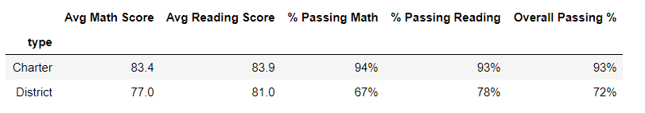

1. Schools of small to medium size also exhibit a distinct performance advantage to those of larger sizes. It should be considered that many charter schools fall into the small to medium student body size. See appendix for school summary.

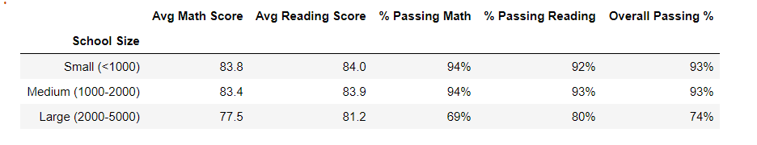

1. Surprisingly per student spending does not affect student performance as much as school size and type.

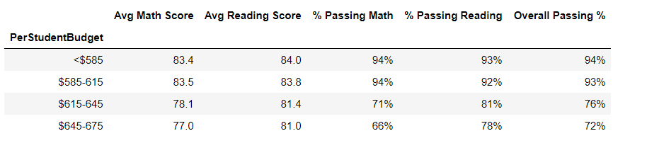

Appendix:

School Summary

